Laboratory Activity 3 : Responsive Design - Build, Break, and Fix a Layout

Bachelor of Science in Information Technology
UI / UX and Cross Platform
Mr. Jober Salvador - Subject Instructor

Group Members:

Rondilla, Precious C.
Tolentino, Mariely Ann L.
Villafranca, Carla Mae R.

August 2026
Part A. Responsive Design Fundamentals (Week 5)

Html File (Code)

<!DOCTYPE html>
<html lang="en">
<head>
<meta charset="UTF-8">
<meta name="viewport" content="width=device-width, initial-scale=1.0">
<title>Palmera Resort – Book Your Escape</title>
<link rel="stylesheet" href="style.css">
</head>
<body>

<!-- HEADER -->
<header>
<div class="container header-inner">
<div class="logo">🌴 Palmera Resort</div>

<!-- Hamburger button (visible on mobile only) -->
<button class="nav-toggle" id="navToggle" aria-label="Toggle navigation" aria-expanded="false">
<span class="bar"></span>
<span class="bar"></span>
<span class="bar"></span>
</button>

<nav id="mainNav">
<a href="#">Home</a>
<a href="#">Rooms</a>
<a href="#">Amenities</a>
<a href="#">Book Now</a>
</nav>
</div>
</header>

<!-- HERO SECTION -->
<section class="hero">
<div class="container hero-inner">
<div class="hero-text">
<h1>Your Perfect Beach Getaway Awaits</h1>
<p>Escape the everyday at Palmera Resort — where crystal-clear waters, lush tropical gardens, and world-class service come together for an unforgettable stay. Book your room today and enjoy exclusive early-bird rates.</p>
<a href="#" class="btn-book">Book Now</a>
</div>
<div class="hero-image">
<img src="https://images.unsplash.com/photo-1507525428034-b723cf961d3e?w=880&h=600&fit=crop" alt="Aerial view of Palmera Resort beachfront">
</div>
</div>
</section>

<!-- CONTENT SECTION -->
<section class="content">
<div class="container">
<h2 class="section-title">Why Stay With Us?</h2>
<div class="content-inner">

<div class="column">
<img src="https://images.unsplash.com/photo-1520250497591-112f2f40a3f4?w=560&h=360&fit=crop" alt="Beachfront villas">
<h3>Beachfront Villas</h3>
<p>Wake up steps from the shore in our spacious beachfront villas. Each room features a private balcony with panoramic ocean views and a king-size bed.</p>
</div>

<div class="column">
<img src="https://images.unsplash.com/photo-1571896349842-33c89424de2d?w=560&h=360&fit=crop" alt="Infinity pool">
<h3>Infinity Pool & Spa</h3>
<p>Unwind in our signature infinity pool overlooking the sea, then restore your body and mind at our full-service wellness spa.</p>
</div>

<div class="column">
<img src="https://images.unsplash.com/photo-1414235077428-338989a2e8c0?w=560&h=360&fit=crop" alt="Resort restaurant">
<h3>Farm-to-Table Dining</h3>
<p>Savor fresh local flavors at our open-air restaurant. Our chefs craft every dish from seasonal ingredients sourced straight from nearby farms and waters.</p>
</div>

</div>
</div>
</section>

<!-- FOOTER -->
<footer>
<div class="container footer-inner">
<p>&copy; 2026 Palmera Resort. All rights reserved.</p>
<div class="footer-links">
<a href="#">Privacy Policy</a>
<a href="#">Terms & Conditions</a>
<a href="#">Contact Us</a>
</div>
</div>
</footer>

<script>
const toggle = document.getElementById('navToggle');
const nav = document.getElementById('mainNav');

toggle.addEventListener('click', function () {
const isOpen = nav.classList.toggle('nav-open');
toggle.classList.toggle('nav-toggle--open', isOpen);
toggle.setAttribute('aria-expanded', isOpen);
});

// Close menu when a link is tapped
nav.querySelectorAll('a').forEach(function (link) {
link.addEventListener('click', function () {
nav.classList.remove('nav-open');
toggle.classList.remove('nav-toggle--open');
toggle.setAttribute('aria-expanded', 'false');
});
});
</script>
</body>
</html>

CSS File (Code)

/* =====================
RESET & BASE
===================== */
* {
margin: 0;
padding: 0;
box-sizing: border-box;
}

body {
font-family: Georgia, "Times New Roman", serif;
font-size: 100%; /* 1rem = 16px in most browsers */
color: #222222;
background-color: #f4f4f4;
}

/* All images are fluid by default */
img {
max-width: 100%;
height: auto;
display: block;
}

/* =====================
FLUID CONTAINER
— max-width replaces fixed 960px
— percentage padding gives breathing room
===================== */
.container {
max-width: 60rem; /* 960px ÷ 16 = 60rem */
width: 100%;
margin: 0 auto;
padding: 0 1.25rem; /* 20px */
}

/* =====================
HEADER
===================== */
header {
background-color: #1a1a2e;
padding: 0 1.25rem;
}

.header-inner {
display: flex;
align-items: center;
justify-content: space-between;
height: 4.375rem; /* 70px */
}

.logo {
font-size: 1.625rem; /* 26px */
font-weight: bold;
color: #e0e0e0;
letter-spacing: 0.125rem;
}

nav a {
color: #cccccc;
text-decoration: none;
margin-left: 1.75rem; /* 28px */
font-size: 0.9375rem; /* 15px */
font-family: Arial, sans-serif;
letter-spacing: 0.03em;
}

nav a:hover {
color: #ffffff;
text-decoration: underline;
}

/* Hamburger button — hidden on desktop & tablet */
.nav-toggle {
display: none;
flex-direction: column;
justify-content: center;
gap: 0.3rem;
background: none;
border: none;
cursor: pointer;
padding: 0.25rem;
z-index: 100;
}

.nav-toggle .bar {
display: block;
width: 1.625rem; /* 26px */
height: 0.1875rem; /* 3px */
background-color: #e0e0e0;
border-radius: 0.125rem;
transition: transform 0.25s ease, opacity 0.25s ease;
}

/* Animate bars into an X when open */
.nav-toggle--open .bar:nth-child(1) {
transform: translateY(0.4875rem) rotate(45deg);
}
.nav-toggle--open .bar:nth-child(2) {
opacity: 0;
}
.nav-toggle--open .bar:nth-child(3) {
transform: translateY(-0.4875rem) rotate(-45deg);
}

/* =====================
HERO SECTION
===================== */
.hero {
background-color: #16213e;
padding: 3.75rem 1.25rem; /* 60px 20px */
}

.hero-inner {
display: flex;
align-items: center;
gap: 2.5rem; /* 40px */
}

.hero-text {
flex: 1 1 48%; /* fluid, roughly half */
}

.hero-text h1 {
font-size: 2.625rem; /* 42px */
color: #ffffff;
line-height: 1.2;
margin-bottom: 1.25rem;
}

.hero-text p {
font-size: 1.0625rem; /* 17px */
color: #bbbbbb;
line-height: 1.7;
font-family: Arial, sans-serif;
margin-bottom: 1.75rem;
}

.btn-book {
display: inline-block;
background-color: #e8a838;
color: #1a1a2e;
text-decoration: none;
font-family: Arial, sans-serif;
font-size: 1rem;
font-weight: bold;
padding: 0.75rem 2rem;
border-radius: 0.25rem;
letter-spacing: 0.04em;
transition: background-color 0.2s ease;
}

.btn-book:hover {
background-color: #f0bc55;
}

.hero-image {
flex: 1 1 46%; /* fluid, roughly half */
}

.hero-image img {
width: 100%;
height: auto;
border: 0.25rem solid #0f3460;
border-radius: 0.375rem;
}

/* =====================
CONTENT SECTION
===================== */
.content {
background-color: #ffffff;
padding: 3.75rem 1.25rem;
}

.section-title {
font-size: 1.75rem;
color: #1a1a2e;
text-align: center;
margin-bottom: 2rem;
font-family: Arial, sans-serif;
}

.content-inner {
display: flex;
gap: 1.25rem; /* 20px */
}

.column {
flex: 1 1 0; /* equal fluid thirds */
min-width: 0; /* prevents flex overflow */
background-color: #f9f9f9;
border: 1px solid #dddddd;
padding: 1.25rem;
}

.column h3 {
font-size: 1.25rem; /* 20px */
color: #1a1a2e;
margin-bottom: 0.875rem;
font-family: Arial, sans-serif;
}

.column img {
width: 100%;
height: auto;
margin-bottom: 0.875rem;
border: 1px solid #cccccc;
border-radius: 0.25rem;
}

.column p {
font-size: 0.9375rem; /* 15px */
color: #444444;
line-height: 1.65;
font-family: Arial, sans-serif;
}

/* =====================
FOOTER
===================== */
footer {
background-color: #1a1a2e;
padding: 1.5rem 1.25rem;
}

.footer-inner {
display: flex;
flex-direction: column;
align-items: center;
justify-content: center;
gap: 0.75rem;
text-align: center;
}

footer p {
color: #888888;
font-size: 0.875rem; /* 14px */
font-family: Arial, sans-serif;
}

.footer-links a {
color: #aaaaaa;
text-decoration: none;
font-size: 0.875rem;
font-family: Arial, sans-serif;
margin-left: 1.25rem;
}

.footer-links a:hover {
color: #ffffff;
text-decoration: underline;
}

/* ================================================
DESKTOP (1025px and above)
Base styles already handle this breakpoint.
Container is capped at 60rem; nothing else changes.
================================================ */
@media (min-width: 64.0625em) { /* 1025px */
/* No overrides needed — base styles are desktop-first */
}

/* ================================================
TABLET (481px – 1024px)
================================================ */
@media (min-width: 30.0625em) and (max-width: 64em) { /* 481px–1024px */

/* Header: keep logo + nav on one line, tighten gaps */
header {
padding: 0.875rem 1.25rem;
}

.header-inner {
height: auto;
flex-wrap: wrap;
gap: 0.625rem;
}

.logo {
font-size: 1.375rem;
}

nav a {
margin-left: 1.125rem;
font-size: 0.875rem;
}

/* Hero: stack text above image */
.hero {
padding: 2.5rem 1.25rem;
}

.hero-inner {
flex-direction: column;
align-items: flex-start;
gap: 1.5rem;
}

.hero-text {
flex: 1 1 100%;
}

.hero-text h1 {
font-size: 2rem;
}

.hero-text p {
font-size: 1rem;
}

.hero-image {
flex: 1 1 100%;
}

/* Content: two columns */
.content {
padding: 2.5rem 1.25rem;
}

.content-inner {
flex-wrap: wrap;
gap: 1.25rem;
}

.column {
flex: 1 1 calc(50% - 0.625rem); /* two per row */
}

.column h3 {
font-size: 1.125rem;
}

/* Footer: stack copyright above links */
.footer-inner {
flex-direction: column;
align-items: center;
gap: 0.625rem;
text-align: center;
}

.footer-links a {
margin-left: 0;
margin-right: 1rem;
}
}

/* ================================================
MOBILE (up to 480px)
================================================ */
@media (max-width: 30em) { /* 480px */

body {
font-size: 93.75%; /* ~15px base */
}

/* Header: show hamburger, hide nav by default */
header {
padding: 0 1rem;
position: relative;
}

.header-inner {
height: 3.75rem;
flex-wrap: nowrap;
align-items: center;
}

.logo {
font-size: 1.25rem;
}

/* Show the hamburger button */
.nav-toggle {
display: flex;
}

/* Hide nav links by default on mobile */
nav#mainNav {
display: none;
flex-direction: column;
position: absolute;
top: 3.75rem;
left: 0;
right: 0;
background-color: #1a1a2e;
padding: 1rem 1.25rem 1.25rem;
gap: 0;
z-index: 99;
border-top: 1px solid #2e2e4e;
}

/* Show nav when toggled open */
nav#mainNav.nav-open {
display: flex;
}

nav#mainNav a {
margin-left: 0;
padding: 0.75rem 0;
font-size: 1rem;
border-bottom: 1px solid #2e2e4e;
color: #cccccc;
}

nav#mainNav a:last-child {
border-bottom: none;
}

nav#mainNav a:hover {
color: #ffffff;
text-decoration: none;
padding-left: 0.5rem;
}

/* Hero: single column, smaller heading */
.hero {
padding: 1.875rem 1rem;
}

.hero-inner {
flex-direction: column;
align-items: flex-start;
gap: 1.25rem;
}

.hero-text {
flex: 1 1 100%;
}

.hero-text h1 {
font-size: 1.625rem;
}

.hero-text p {
font-size: 0.9375rem;
}

.hero-image {
flex: 1 1 100%;
}

/* Content: single column */
.content {
padding: 1.875rem 1rem;
}

.content-inner {
flex-direction: column;
gap: 1.25rem;
}

.column {
flex: 1 1 100%;
}

.column h3 {
font-size: 1.125rem;
}

.column p {
font-size: 0.875rem;
}

/* Footer: stacked */
footer {
padding: 1.25rem 1rem;
}

.footer-inner {
flex-direction: column;
align-items: center;
gap: 0.75rem;
text-align: center;
}

.footer-links {
display: flex;
flex-wrap: wrap;
gap: 0.625rem;
}

.footer-links a {
margin-left: 0;
font-size: 0.8125rem;
}

footer p {
font-size: 0.8125rem;
}
}

Screenshots

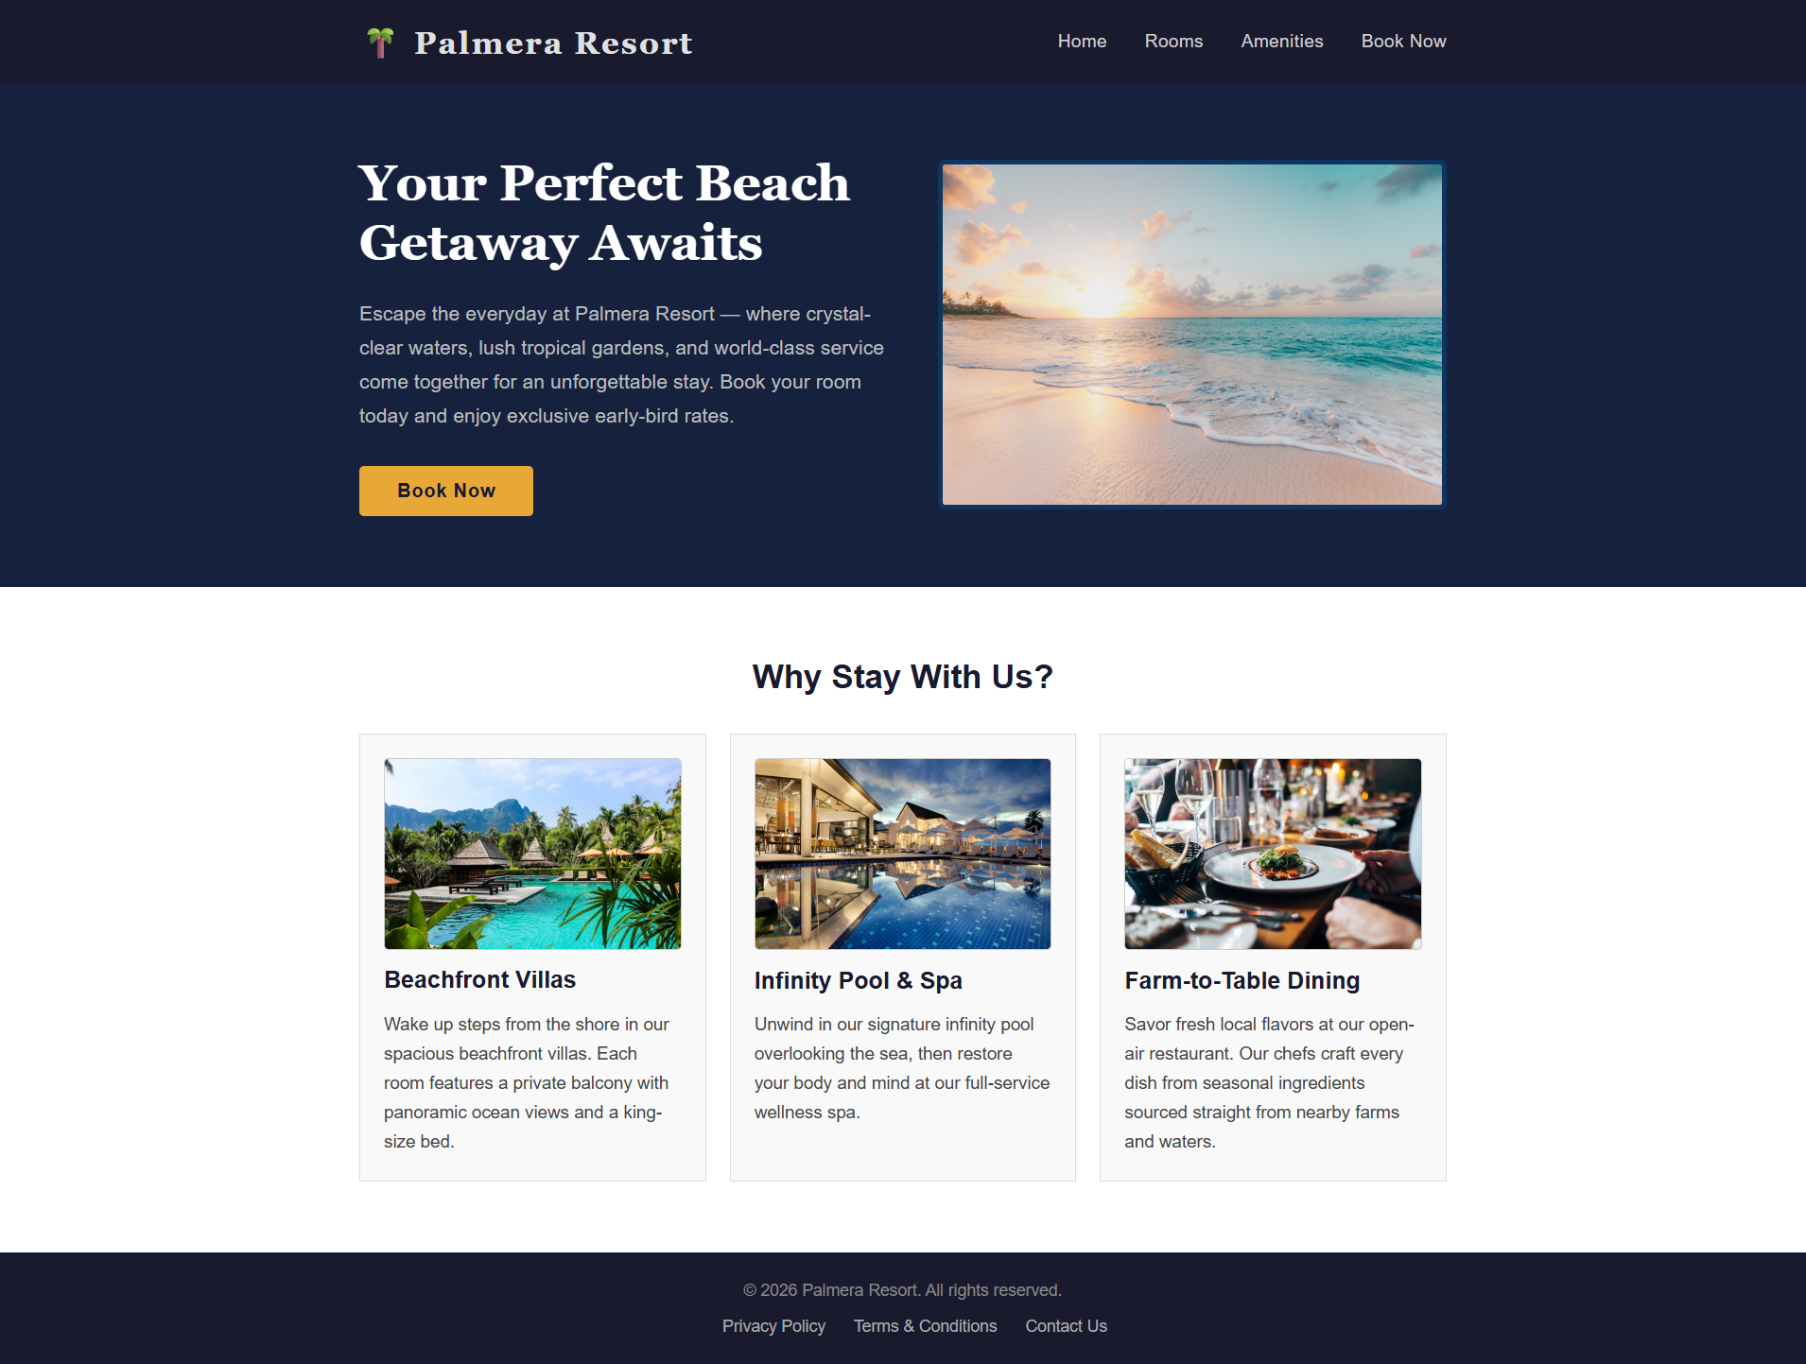
Desktop

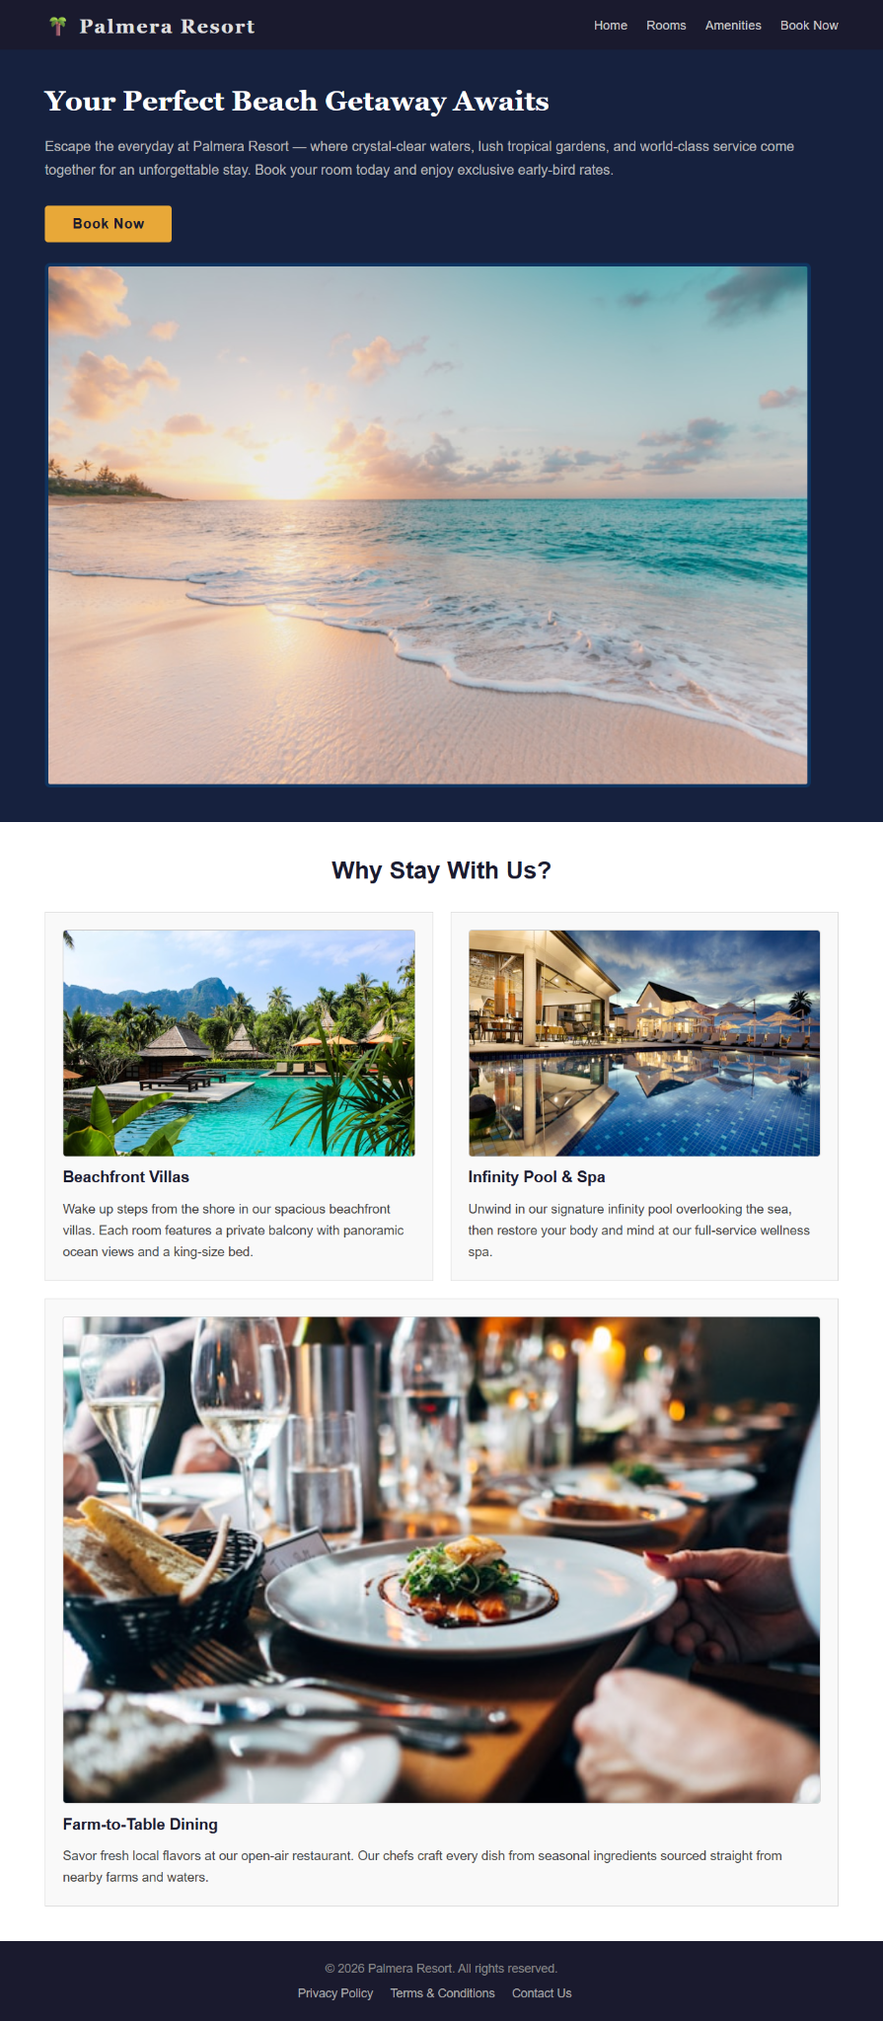
Tablet

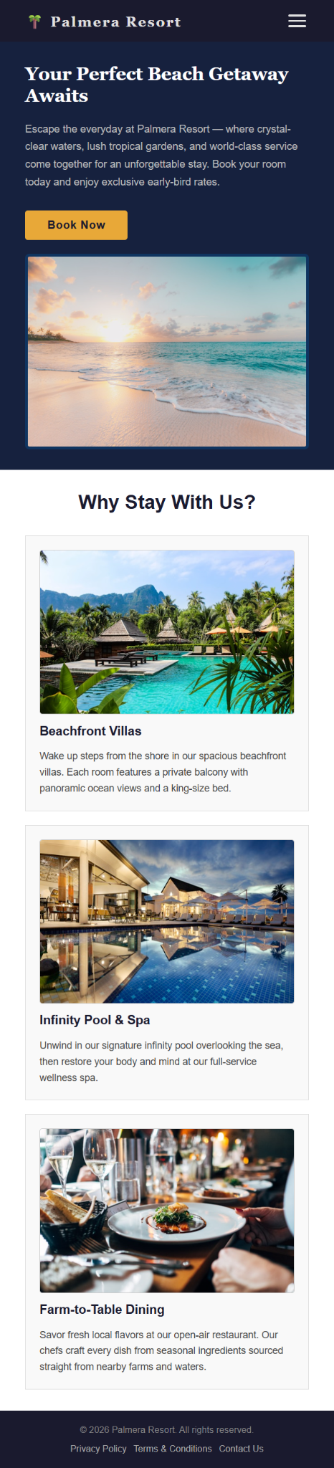
Mobile

What Broke and How It Was Fixed?

The original layout used a hard-coded 960px container, so on any screen narrower than 960px the entire page overflowed horizontally and required sideways scrolling. The hero section had a fixed 460px text block and a 440px image sitting side by side, which meant they never stacked on small screens and the image was simply cut off. The three content columns were each set to a fixed 300px width, so on a narrow viewport they spilled outside the container instead of wrapping or resizing.

To fix these issues, the container was changed from `width: 960px` to `max-width: 60rem` with `width: 100%`, letting it shrink fluidly on smaller screens. All fixed pixel widths were replaced with relative units (`rem`, `%`, `flex`) so the layout stretches and shrinks proportionally, and a global `max-width: 100%; height: auto` rule was added to all images so they never overflow their container. Three media query breakpoints were added desktop (1025px+), tablet (481px–1024px), and mobile (up to 480px) each adjusting layout, font sizes, and spacing: the hero and content columns stack vertically on tablet and mobile, and the footer centers its content at every breakpoint. On mobile, the horizontal navigation was replaced with a hamburger menu button that toggles a full-width dropdown drawer, keeping the header clean and usable on small screens.

